Mission to the Eagles

Michael Wild

AME notes on Mission to the Eagles.

Version 0.0.1

Fan work

Notes on Mission to the Eagles 2
The Price of Success is Opportunity 2
Well met 3
Additional Items 3
The Journey 4
Entering Mirkwood 4
The King 4
Spiders In Mirkwood 5
The Wood Wight 6
Around Mirkwood 6
Spiders Loosened 6
Unexpected Guest 7
The Unexpected Audience 7
The Wood Wight Tracking them 7
The East Upper Vale 8
Slavers! 8
Slave Lands 8
East Middle Vales: The End of the Journey. 9
Audience with Beorn 9
Audience with the Lord of the Eagles 9
Audience with Elrond 10
Monsters 11
Additional handouts 17
About the AuthoR 18

Notes on Mission to the Eagles
This is an extension of an adventure supplied in The One Ring RPG book section 9 to work with AME. This is just a reworking of the material to allow its use now. The Heart of The Wild (HW) book is also used to supply material. This is fan work.

The players have completed the Marsh Bell found in The One Ring and now have a chance to complete the mission that Balin and Oin attempted by another road.

Player characters are assumed to be second level.

The Price of Success is Opportunity
The opportunity is that the mission that Balin and Oin undertook in the previous adventure, The Marsh Bell provided in the The One Ring, needs to still be fulfilled. Balin and Oin are ordered by their King to remain for the time being at the Lonely Mountain. Later they will argue that they must take back Moria and try to stay some of the darkness they have seen. But that is later story. For the moment the players have an audience with Gloin in Lake-town.

The story here includes the reason Balin heads out later and why the elves of Mirkwood fade from the later story.

Well met
The players must have an audience with Gloin. The PC’s are treated as Favored as results of the previous play, and get an advantage die. The players learn that they are invited to another mission. They are to complete the journey to the Eagles.

Gloin’s words follow. The LM may use or paraphrase:
My brave adventurers, you look good in new arms and gifts from our King. But weapons and items like that are not for polish. Who wants an axe with a perfect blade—those nicks are what make the axe. That is what we dwarves say.

I must be growing old, polished words are not my specialty—as you know already. It is time to add a few marks to the armor, a bit of dust on our cloaks, a chance to test our manors too, and all for a mission once secret and kept close: Our treaty to the Eagles.

Yes we need you to carry the chest and its contents to the King of the Eagles.

You are to travel north to avoid the dangers of the south. You may travel to the Mirkwood and try your luck with the elves. We suggest avoiding their hospitality and instead take the same route Gandalf took half a decade ago with the esteemed Mr. Baggins—that is to go north and around Mirkwood. It was more deadly in those days, but still it is strange. You should head to Beorn’s house and then go to the Eagles. Let Beorn introduce you—The Eagles are an old proud race. Give them the box and treaty.

The box is described in The One Ring pages 293-4. As described in the book the gem is from the dragon’s horde and is perilous. Anyone who sees it will need to make a corruption check (DC10 as they recovered it and this helps them to resist the desire to own the gem) or gain a shadow point. All will know that it is perilous and will keep it in the box.

Notes: LM needs to record anyone who gains a shadow point from the seeing the gem. If they become miserable they might steal the gem instead of their regular madness.

Assuming the audience went well, Gloin will provide them with horses and ponies and supplies for a trip around Mirkwood. If the players decide on the forest then the horses and ponies are to be released at the forest, “No, the horses and ponies will not be of much use in the forest so release them at the entrance and they will find their way back to Dale,” grumbles Gloin on hearing that the PCs are headed for Mirkwood.

Additional Items
The enemy is watchful. His spies are in Dale and he wishes to cause mischief. The players can learn more about the areas they travel in.

The players may try to investigate and learn more about where they headed. A DC 15 will get the more interesting items below:

- Frar the Beardless is available in Dale. He has just again been turned down by the King Under-the-mountain to reclaim his homeland, the Greydelve. To pass around Mirkwood they PCs will need to pass thru Frar the Beadless’s homeland. He can give them advice if they befriend him (See The Heart of the Wild, pages 19, 22).

- The PCs may also learn of a strange man who visits with travelers in the Grey Mountain Narrows (see page 21 HW).

- If the PCs speak with any Mirkwood elves at Dale they might learn that spiders have been attacking more than normal, “Something drives them to us,” will say an elf quietly over some wine.

- Anyone recently travelling the same road will report of signs of orcs in the area. “That smell is known to all,” will warn a traveler.

- A trader says that the elves have sealed their borders again. “Troubles come,” says one travelling tinker with sadness.

The players alert the enemy if they roll a one on a skill check. Again, another PC might spot the agent if this happens. The agent will be a local mill owner.

The Journey
The journey should be planned according to the rules with the players planning a route. The LM should remind them to make trips short, as they are new adventurers. Their first choice will be to choose if they will enter Mirkwood or go around it.

They need to cover all the positions in a journey and then begin (see rules on taking a journey). They have supplies from Gloin—cram and dried meats and fruits. Even a few fruit cakes.

The trip will take the players either to the edge of Mirkwood or to the Eastern Gate. The gate is manned by elves and they will stop anyone trying to enter. They will explain that the King desires no more loss of life in the forest as the path has become dangerous.

Entering Mirkwood
This is an audience with the guards. They will not let folks enter the forest unless they are headed to halls of the King or have a very good reason. This means a roll of DC15 or better to reach the halls of the King. A DC 20 would be needed to get enter the path.

The King
The King Thranduil (see HW pages 75-76) will either meet the PCs at his hall or on an encounter (see below).

The PCs can travel a few days in for forest to reach the Halls of Thranduil (HW page 80) and have an audience with the King. He will be Favorable towards them.

This is the words the LM may use:
Good friends from near and afar. I have heard of your deeds and I am sorry in such dark times we did not know the difficulties our bearded friends found deep in the shadows of drowned woods.

We approve of your mission and ask not to speak more if it.

Allies we need and often it is good to remind our allies we still need them and respect them.

We wish to append to your mission. Once complete please do not return to Dale but travel to Elrond and tell him this: ‘We are besieged in our own forest by his darkness. Look for no aid from us, but we will take on all the darkness brought to us and keep it here in our forest. Tell our allies we fight our own battles and will allow others to fight on with other battles yet to come. Weep for the forest, but know we will darken but not fall!’ Tell these words to Elrond for us.

Once your mission is complete headed for the high pass known to many as the mountain Caradhras and Red Horn Gate. Beware of goblins in the other passes. Then travel to Elrond to make the passage. Our wisdom is that you finish your mission, visit the Beorn, and get supplies and advice from him to start a new journey.

Please know that the Elf-Path is dangerous and I cannot spare you an escort should you turn in that direction as we are attacked from multiple ways. You have traveled dark paths before and know how to fight—I trust you will soon be able to show the dwarves that you have used their goods well.

We wish you well on your travels and hope that our hospitality is never unlooked for.

The King has required an additional quest of the adventurers and he is not expecting to be turned down or bargained with. He wishes them to finish their delivery to the Eagles and then to entering into another journey to carry his message to Elrond. He promises, if asked, to let The King-Under-The-Mountain know that they completed their mission. “Have Beorn tell us that you reached the Eagles and all will be well—He will tell us and we will carry that to Gloin and his King,” the King states with a bit of irony in his voice like he is speaking to a tinker.

Spiders In Mirkwood
The spiders have attacked the elves and have laid traps in the paths the PCs will take. The PCs may avoid the traps, fight them, or fall victim to them.

There are three nests of spiders on the Elf-Path that crosses Mirkwood now. Three sets of checks are made. The LM asks the scout for a check, if made the spiders might be avoided. The LM asks for a check from the guide, DC 15. If made the spiders are avoided (on a 20 or better the guide spots an elf and soon the nest is destroyed by the elves—a shadow point is removed from adventurers) and the LM moves to the next nest of spiders. If the spiders cannot be avoided or were not noticed, combat ensues. If the lookout check is made there is no surprise. If the look-out check is failed then each PC makes a corruption check, those who fail fall into a web as part of the surprise round, no more than two PCs should fall into webs.

For the battle map use a forest map with a small path in it. The number of spiders is the same as the number of players.

The spiders can speak. Here are texts for each nest.
Nasty little flies we have today. Oh they look well-fed, lots of nice juices.

Lie down now and sleep my good pets. I can help you sleep here in my webs.

We have heard that there is fresh strong meat on the path.

If spiders overwhelm the PCs the elves rescue them from being dinner (the spider venom will make a PC pass their death save and stabilize so anyone knocked to zero hit points is also rescued). The PCs each earn one point of shadow if the spiders take them. The elves will heal the PCs and get them back on their path and train them a bit on how to avoid the nests. “See the strange patterns in the leaves, that is a web in the leaves—a nest is near.” The PCs will then have an advantage die for their scout and guide to avoid the next nest.

The Wood Wight
The elves fear that far worse have been released into their forest and the PCs have found that they are right. A horror of undead tracks them. Mirkwood is dark so the wight is never in sunlight.

The scout has seen tracks that suggest something or horror hunts them. Clawed feet that look human but are frozen into the ground and leave the plants next to the steps withered. A DC15 will allow the scout to warn that it is coming closer. A lookout check DC16 (+4 for being a wight and +2 because it is in a natural setting) will prevent it from surprising the adventurers. The PCs can try to ambush it by comparing their stealth to the wood wight’s perception roll.

The wight does not do energy drain as per the SRDF. Instead a hit inflicts one shadow point to the affected target as it brings the character into more misery and does five points damage that cannot be healed until a long rest. It will use one sword hit and one drain attack.

It is a weak agent of the Enemy created by tying an elf to a tree and exposing them to raw power of a Nazgul’s ring. The tree and the elf die and become undead together.

Around Mirkwood
The trip around is from the Lonely Mountain to The Gray Mountain Narrows and then to the East Upper Vale and finally to the East Middle Vale.

Spiders Loosened
The spiders have been driven from the forest and now track food in The Gray Mountains Narrows. The have spotted the PCs on the hills and are hungry.

If the look-out check is made there is no surprise.
For the battle map use an open spaces map. The LM should use two more spiders than the count of players.

The spiders can speak. Here are texts for each nest.
Nasty little wander bugs we have today. Oh they look well-fed, lots of nice juices.

Lie down now and sleep my good hill children. I can help you sleep here in my webs.

We have heard that there is fresh strong meat in these hills.

If spiders overwhelm the PCs some travelling dwarves rescue them from being dinner (the spider venom will make a PC pass their death save and stabilize so anyone knocked to zero hit points is also rescued). The PCs each earn one point of shadow if the spiders take them. The dwarves having heard of the PCs exploits will heal the PCs and get them back on their road.

Unexpected Guest
The PCs will meet up with Farmann (see HW page 21).

The Unexpected Audience
King Thranduil has been hunting the evil that has flooded his forest. He is less interested in courtly manors in the field and happy to find the well-armed adventurers so the audience is with an advantage die, and +2, and is Favored. Assume the PCs are near Mirkwood and suddenly see the elves. Thranduil will forgive that they PCs do not bow immediately as he knows the effect of the show he has puts on.

Some text:
The edge of Mirkwood is alive with elves they come pouring out in perfect lines as if going to war. Banners are hoisted once the tree line is cleared and a grave set of warrior Mirkwood elves form a block and march before you. They split into two sets of rows in perfect movements that cause you to gasp and they turn to face inward. The King of Mirkwood, Thranduil in war armor walks towards you between the ranks. He seems to be expecting you to perform the correct form of welcome as he walks to you. His sword is not drawn—that is good.

See The King above for the text and notes about the next quest for the PCs.

The Wood Wight Tracking them
The elves fear that far worse have been released into their forest and the PCs have found that they are right. A horror of undead tracks them leaving Northern Mirkwood, travelling at night from dark hole to next dark hole.

The scout has seen tracks that suggest something or horror hunts them. Clawed feet that look human but are frozen into the ground and leave the plants next to the steps withered. A DC15 will allow the scout to warn that it is coming closer. On a roll of twenty or higher the wight is found in a small cave during the day and is trapped by the PCs.

The wight will attack after midnight, given that chance, while the PCs are resting. If the lookout check fails it attacks with surprise. It will use one sword and one drain attack.

As mentioned above, the wight does not do energy drain as per the SRDF. Instead a hit inflicts one shadow point to the affected target as it brings the character into more misery and does five points damage that cannot be healed until a long rest.

The players should make two random events on their journey ignoring events for agents of good or bad—those were already played.

The East Upper Vale
This area is still under slavery and dark command. The PCs will know they are in a land of barbarians and slavers. Any Beorning will not wish to enter this area and no it is not safe and a slave state. The LM can have the player explain this if a Beorning.

Slavers!
A group of orcs slavers will track the PCs from the Dust Mouth (HW page 31) and try to over take them. The orcs have chains and metal cages for slaves with them—clearly they are slavers and not agents of Sauron. They are independent contractors.

If the scout makes a DC15 check he or she spots them first. If the guide can then make a DC15 check he or she manages to hide the PCs from the orc slavers. If the guide check fails the PCs can try to out distance them on their horses and ponies. This requires an endurance or dexterity check of DC10. The orcs will not try that hard—they like easy prey. For each failure another PC with a success may try to help the PC who failed recover. Thus if one PC failed another PC, just one, could try to help them. If that attempts fail then the PCs are unable to out-distance the orcs. The orcs will throw javelins at the PC horses. Any hit will likely badly hurt the horse and panicked creature will try to throw its rider (DC10 check).

The orcs are using clubs and doing non-lethal damage; they want new alive slaves to sell. The orcs do six points of non-lethal damage per hit with their clubs.

If the players manage to loose due to bad luck or poor planning, that is they are knocked out and captured. They will awaken to the smell of burning orcs and the head of the orcs on posts made from the orc clubs. A dwarf will be smoking a pipe and smiling at them.

Read or paraphrase:
“Laddie, you nearly were assigned to a plow! You need to be more careful,” says the dwarf. “Luckily our birds fly faster than your ponies ride. Yes, we kept an eye on you in this cursed land. Slavers! Bah! Makes me want to pound something more than iron. Us Iron Dwarves took a bit gold from the King-Under-The-Mountain to ensure no slaving from the damn orcs. Had to help after what happened to the previous King-Under-The-Mountain. Call me Ivan in your tongue. Ivan the Lucky,” he says while smoking and nearly choking a few times.

The PCs each earn one point of shadow if the orc slavers take them and have to be rescued. Ivan will leave them once they are back on their way. He can supply a replacement pony and horse. “Not my first slavers’ I defeated today,” he says as he gives over the horse and/or pony. “I am sure they will like you better than their previous masters,” he says with a smile.

Slave Lands
As the adventurers travel though this land they will see folks of various cultures enslaved.

Read or paraphrase:
As you pass by farms you see the works chained and dirty and looking starved and miserable. The land has returned to older times when slavery existed. You thought Gondor’s Lords had stomped out this fowl practice years ago. Viglund, you learn, rules this small land and has brought back an iron rule that includes slavery and brigandry. His clan rules here and they fully support him.

The PCs are in no position to take on a man like Vigund. The players should avoid any more trouble in the vale.

There is no corruption here just old-fashioned cruelty.

No events as we have already enough.

East Middle Vales: The End of the Journey
The journey ends here even if the Elf-Path was used. If the Elf-Path is used still have the slavers attack from the above as the Adventurers leave Mirkwood. Have an elf rescue them instead of a dwarf if required with just a few changes in the text.

The Elf-Woods are known for their calming affect. If there is a Beorning in the PCs then they know to build a fire from uncut lumber to feel better. Anyone that attends a blaze of Elf-Woods wood that is not cut from trees will loose one shadow point. The LM can decide if the fire repairs other ills.

A short trip will take the players to Beorn house. One random event should be done, or not.

Audience with Beorn
The players are now able to meet the legendary Beorn following the normal Audience rules. He does not like beggars and he is a bit grumpy. If the players fought slavers and won he will be secretly happy with them, anything to discomfort Vigund. This will give them an advantage die.

Something like this for Beorn:
Why do you come to me? Do you not have other friends and allies? I do not turn away a beggar but you are not that. Why do you come to my doorstep?

If the players come clean and tell him everything he will be very supportive. Roll die after the “interview” as that is part of their audience. If they show him the box they get +4 on their roll.

He will escort them to The Eyre to complete their mission if he believes them. Otherwise he will send them on their way with just a few items, “even beggars and liars are treated fairly here unlike the north—be ye warned.”

Audience with the Lord of the Eagles
The players can stand on The Eyrie and The Lord of the Eagles will come. If they have Beorn with them their audience is with an advantage die and +4. The gift will give them another +2. They will be flow up to Eagles’ home. There they are expected to be very respectful.

The Lord of the Eagles offers to carry the PCs over the mountains or somewhere near by, to Elrond is possible on a successful audience.

The text might go like this:
May the wind always be a friend to you, friends of the Dwarves and messengers of the same thank you for bringing this gift and message from the King Under-The-Mountain. We understand you trip was long and filled with the darkening of our world. Please tell us your story and what is it you want from me.

The players may ask the eagles what they have seen in the area. They will tell them the world seems darker.

Audience with Elrond
The players are carried the Elrond Last Homely Home and there they ask for an audience with the legendary half-elf. As they have a message and have such a unique conveyance they will get an immediate audience. They will get +4 for the audience.

The LM might play Elrond like this:
Friends and allies from near and far, what brings such a unique group to my home in such a hurry? You have come far and strangely. I fear your message as I think it will bring me much pain and my people darkness. Please give me the message from the ruler of what you call Mirkwood.

If all goes well he will replenish their supplies and treat them as honored guests. If they fail then he will still indulge much of their needs, but will send them on. He asks them to guard a trip to dark hills.

Monsters
These are the SRD5 creatures. Placed here for help for the LM.

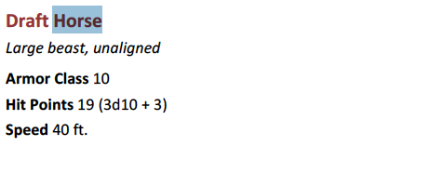
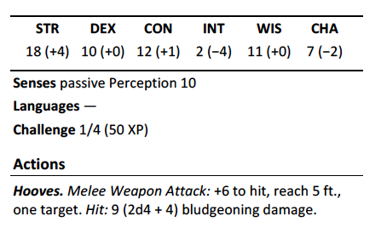

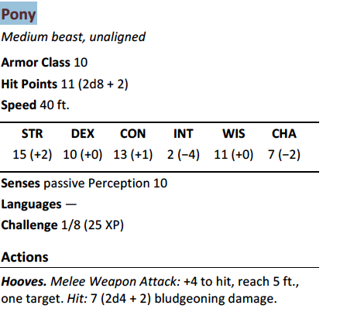
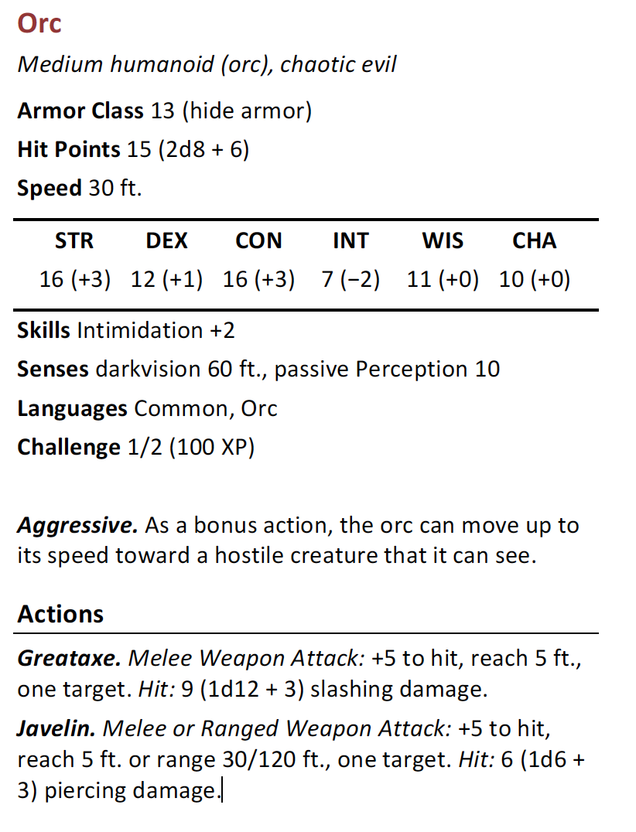

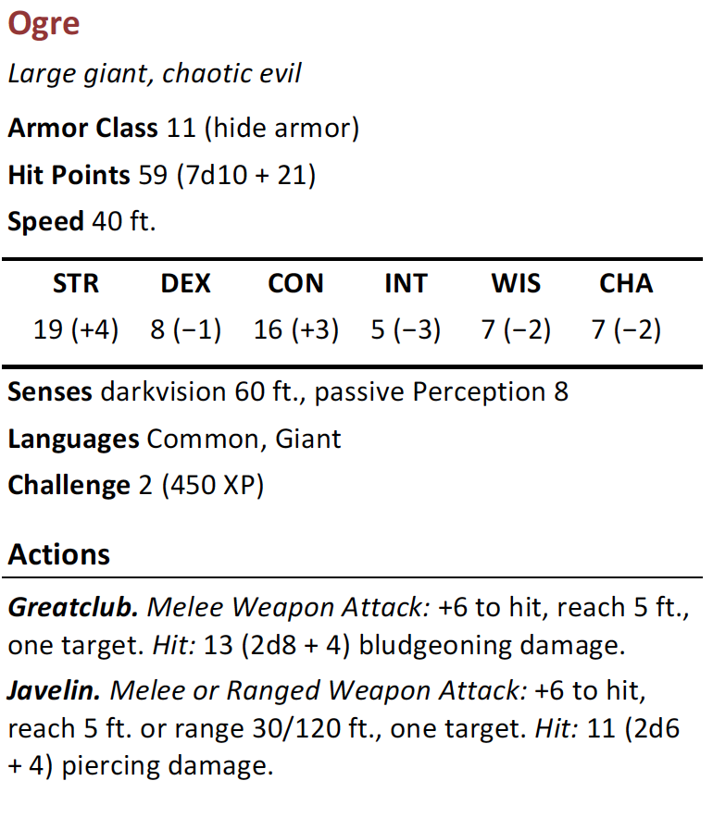
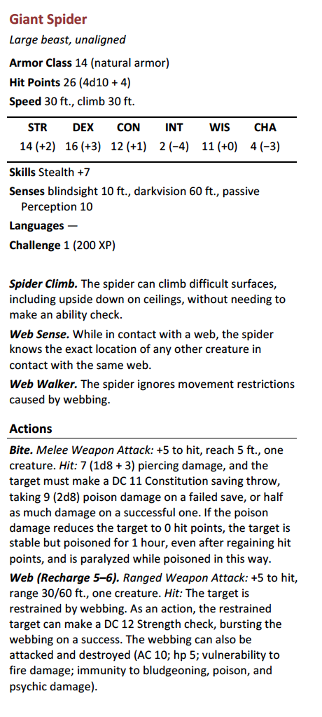

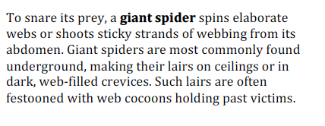

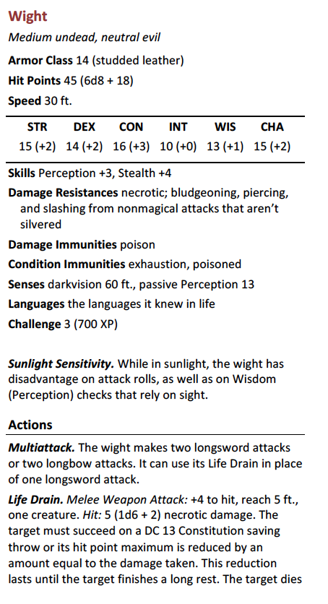

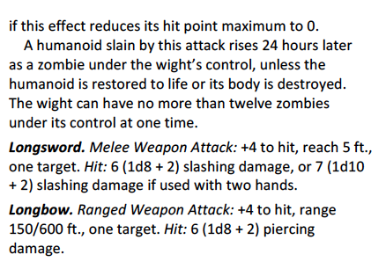

Additional handouts
Here are the additional hand-outs.

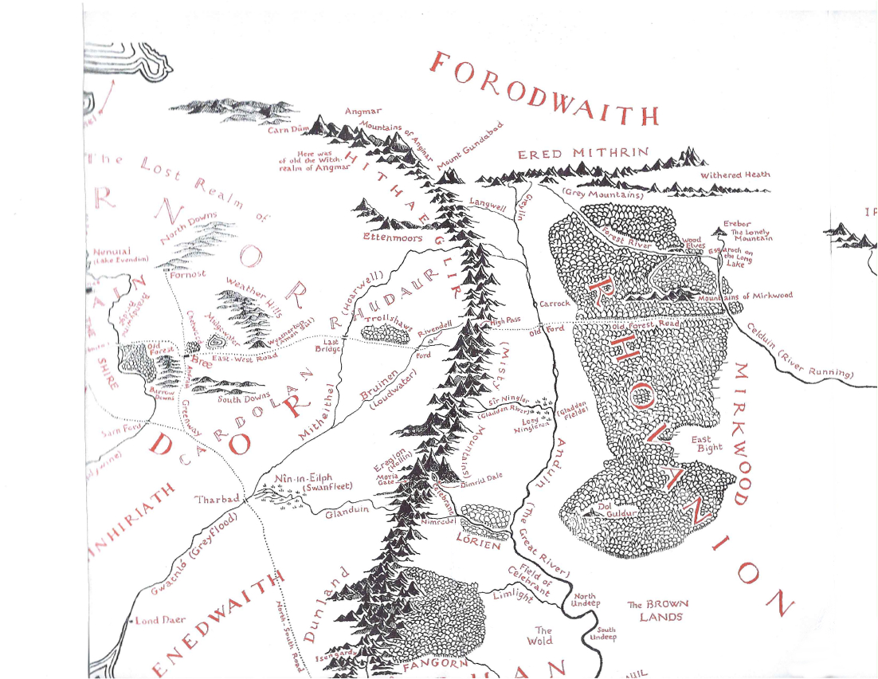

(from LOTR book map and should be in used for private use only)

For a Beorning:

The East Upper Vales is home of the enemy of the Beornings: The Clan of Vilund. They clan is pledged to the end of the Beornings and buy and sell slaves. The go on slaving raids and include fell allies in their consul. Travel through the curse land their means moving as fast as possible to reach the Elf-Woods, the border of Beornings land also known as the East Middle Vales, beforing marked as a possible salable asset.

A fire of Elf-Wood, not cut but collected from fallen wood, will heal much darkness. Bring a load to Beorn is always wise.

About the AuthoR
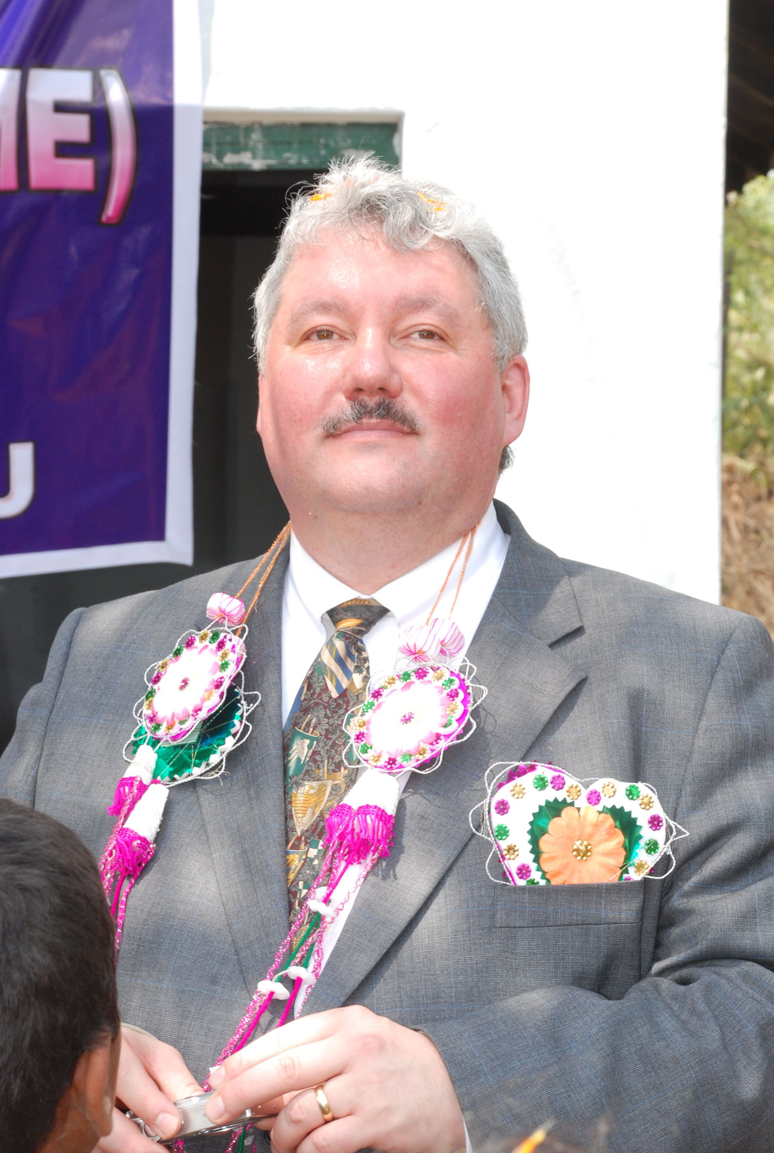
Michael R Wild is the author of many unpublished adventures. He enjoys writing his own adventures for his players. Michael played AD&D in the 1980s but stopped playing after college and did not play again until 3.0 was published. He rewrote some of his AD&D adventures for 3.0 and 3.5 and began to write a lot of 40+ page adventurers from scratch. Michael enjoys writing adventures and playing them. He played 4.0 and all of it changes for years. Michael is starting now on 5.0.

Michael resides in Aloha, Oregon since 1996 with his wife Susan and works at a local shoe company as a computer guy.

All pictures and drawings are from the author—there is nobody else to blame. He is improving his skills.

OPEN GAME LICENSE Version 1.0a

The following text is the property of Wizards of the Coast, Inc. and is Copyright 2000 Wizards of the Coast, Inc ("Wizards"). All Rights Reserved.

1. Definitions: (a)"Contributors" means the copyright and/or trademark owners who have contributed Open Game Content; (b)"Derivative Material" means copyrighted material including derivative works and translations (including into other computer languages), potation, modification, correction, addition, extension, upgrade, improvement, compilation, abridgment or other form in which an existing work may be recast, transformed or adapted; (c) "Distribute" means to reproduce, license, rent, lease, sell, broadcast, publicly display, transmit or otherwise distribute; (d)"Open Game Content" means the game mechanic and includes the methods, procedures, processes and routines to the extent such content does not embody the Product Identity and is an enhancement over the prior art and any additional content clearly identified as Open Game Content by the Contributor, and means any work covered by this License, including translations and derivative works under copyright law, but specifically excludes Product Identity. (e) "Product Identity" means product and product line names, logos and identifying marks including trade dress; artifacts; creatures characters; stories, storylines, plots, thematic elements, dialogue, incidents, language, artwork, symbols, designs, depictions, likenesses, formats, poses, concepts, themes and graphic, photographic and other visual or audio representations; names and descriptions of characters, spells, enchantments, personalities, teams, personas, likenesses and special abilities; places, locations, environments, creatures, equipment, magical or supernatural abilities or effects, logos, symbols, or graphic designs; and any other trademark or registered trademark clearly identified as Product identity by the owner of the Product Identity, and which specifically excludes the Open Game Content; (f) "Trademark" means the logos, names, mark, sign, motto, designs that are used by a Contributor to identify itself or its products or the associated products contributed to the Open Game License by the Contributor (g) "Use", "Used" or "Using" means to use, Distribute, copy, edit, format, modify, translate and otherwise create Derivative Material of Open Game Content. (h) "You" or "Your" means the licensee in terms of this agreement.

2. The License: This License applies to any Open Game Content that contains a notice indicating that the Open Game Content may only be Used under and in terms of this License. You must affix such a notice to any Open Game Content that you Use. No terms may be added to or subtracted from this License except as described by the License itself. No other terms or conditions may be applied to any Open Game Content distributed using this License.

3.Offer and Acceptance: By Using the Open Game Content You indicate Your acceptance of the terms of this License.

4. Grant and Consideration: In consideration for agreeing to use this License, the Contributors grant You a perpetual, worldwide, royalty-free, non-exclusive license with the exact terms of this License to Use, the Open Game Content.

5.Representation of Authority to Contribute: If You are contributing original material as Open Game Content, You represent that Your Contributions are Your original creation and/or You have sufficient rights to grant the rights conveyed by this License.

6.Notice of License Copyright: You must update the COPYRIGHT NOTICE portion of this License to include the exact text of the COPYRIGHT NOTICE of any Open Game Content You are copying, modifying or distributing, and You must add the title, the copyright date, and the copyright holder's name to the COPYRIGHT NOTICE of any original Open Game Content you Distribute.

7. Use of Product Identity: You agree not to Use any Product Identity, including as an indication as to compatibility, except as expressly licensed in another, independent Agreement with the owner of each element of that Product Identity. You agree not to indicate compatibility or co-adaptability with any Trademark or Registered Trademark in conjunction with a work containing Open Game Content except as expressly licensed in another, independent Agreement with the owner of such Trademark or Registered Trademark. The use of any Product Identity in Open Game Content does not constitute a challenge to the ownership of that Product Identity. The owner of any Product Identity used in Open Game Content shall retain all rights, title and interest in and to that Product Identity.

8. Identification: If you distribute Open Game Content You must clearly indicate which portions of the work that you are distributing are Open Game Content.

9. Updating the License: Wizards or its designated Agents may publish updated versions of this License. You may use any authorized version of this License to copy, modify and distribute any Open Game Content originally distributed under any version of this License.

10 Copy of this License: You MUST include a copy of this License with every copy of the Open Game Content You Distribute.

11. Use of Contributor Credits: You may not market or advertise the Open Game Content using the name of any Contributor unless You have written permission from the Contributor to do so.

12 Inability to Comply: If it is impossible for You to comply with any of the terms of this License with respect to some or all of the Open Game Content due to statute, judicial order, or governmental regulation then You may not Use any Open Game Material so affected.

13 Termination: This License will terminate automatically if You fail to comply with all terms herein and fail to cure such breach within 30 days of becoming aware of the breach. All sublicenses shall survive the termination of this License.

14 Reformation: If any provision of this License is held to be unenforceable, such provision shall be reformed only to the extent necessary to make it enforceable.

15 COPYRIGHT NOTICE
Open Game License v 1.0 Copyright 2000, Wizards of the Coast, Inc.

Fellowship Of The Ring, “The Ring Goes South,” page 296.

